|  |  |  |
| --- | --- | --- |
| **Table of Contents** | | |
| Introduction |  |  |
| Welcome |  |  |
| License Agreement |  |  |
| Copyright and Trademarks |  |  |
| Contact Information |  |  |
| Application Window |  |  |
| Control Functions |  |  |
| Connect Button |  |  |
| Disconnect Button |  |  |
| Properties Button |  |  |
| Auxiliary 1 & 2 Button |  |  |
| Enable Logging Checkbox |  |  |
| Clear Data Button |  |  |
| Save Log File Button |  |  |
| Port Selection Field |  |  |
| Baud Rate Selection Field |  |  |
| Temperature Label |  |  |
| Set Point Temperature Label |  |  |
| Stage Remaining Time Label |  |  |
| Stage Label |  |  |
| Elapsed Time Label |  |  |
| Heater label |  |  |
| Auxiliary 1 Label |  |  |
| Auxiliary 2 Label |  |  |
| Log Data Grid |  |  |
| Log Data Chart |  |  |
| Menu Options |  |  |
| File Menu |  |  |
| View |  |  |
| Profile |  |  |
| Log File |  |  |
| Chart File |  |  |
| Chart Image |  |  |
| Save |  |  |
| Log File |  |  |
| Chart File |  |  |
| Chart Image |  |  |
| Page Setup |  |  |
| Print Preview |  |  |
| Print |  |  |
| Exit |  |  |
| Run Menu |  |  |
| Calibrate Oven |  |  |
| Start Reflow |  |  |
| Start Bake |  |  |
| Reset Controller |  |  |
| Configure Menu |  |  |
| Application Settings |  |  |
| Configure RTC |  |  |
| Create/Edit Profile |  |  |
| Upload Profile |  |  |
| Update Firmware |  |  |
| Help Menu |  |  |
| Help Topics |  |  |
| About |  |  |

**Introduction**

**Welcome**

The Reflow Controller application is an optional interface for the reflow controller hardware. The software is designed to

**License Agreement**

Info here

**Copyright and Trademarks**

Info here

**Contact Information**

Info here

**Application Window**

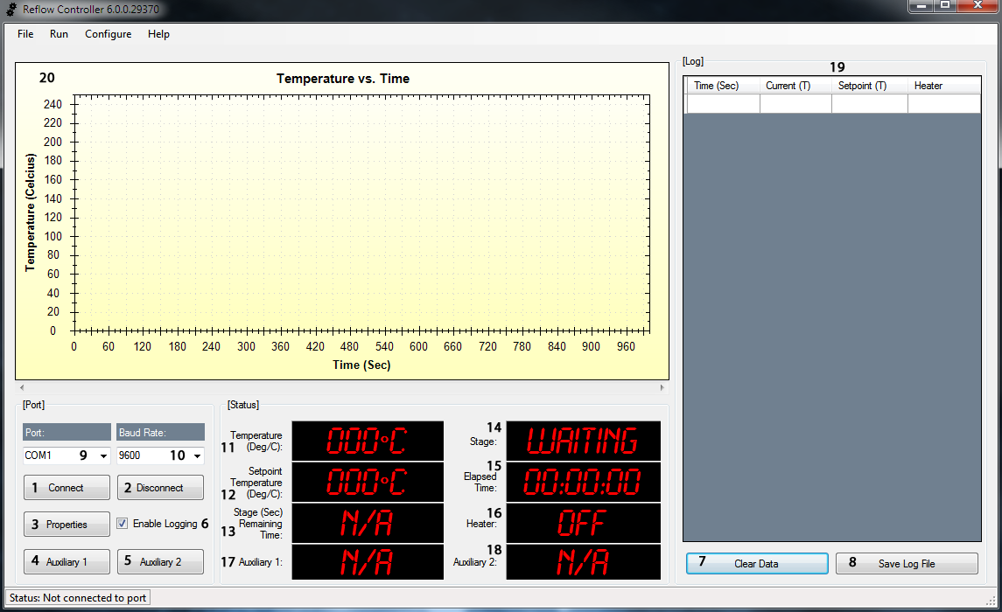

**Control Functions**

1. **Connect Button**

This button establishes a connection to the selected serial port at the selected baud rate if available ports are detected.

1. **Disconnect Button**

This button disconnects from the serial port.

1. **Properties Button**

This button opens the device manager applet so that the serial port properties may be viewed or edited.

1. **Auxiliary 1 Button**

This button will connect or disconnect the device attached to the auxiliary jack.

1. **Auxiliary 2 Button**

This button will connect or disconnect the device attached to the auxiliary jack.

1. **Enable Logging Checkbox**

This checkbox will enable or disable data logging.

1. **Clear Data Button**

This button will clear any data contained in the data grid.

1. **Save Log File Button**

This button will save a log file of data from the data grid to a file compatible with Microsoft Excel or any Excel compatible spreadsheet. The created file can also be opened with a text editor.

1. **Port Selection**

This field is loaded with all detected serial ports and allows a port to be selected for connection. The propertied button should be used to ensure the selected port matches the port the reflow controller is connected to.

1. **Baud Rate Selection**

This field is loaded with available baud rates. The default baud rate for the reflow controller is 9600 baud. The selected baud rate needs to match this setting to ensure proper communication.

1. **Temperature Label**

This label displays the current temperature measurement.

1. **Set Point Temperature Label**

This label displays the set point temperature value.

1. **Stage Remaining Time Label**

This label displays the remaining time for each stage (Preheat, Soak, Heating, Reflow, Cool Down and Bake).

1. **Stage Label**

This label displays the current stage (Preheat, Soak, Heating, Reflow, Cool Down and Bake).

1. **Elapsed Time Label**

This label displays the total time the process is taking.

1. **Heater Label**

This label displays the on/off state of the oven heater relay.

1. **Auxiliary 1 Label**

This label displays the on/off state of the auxiliary 1 device.

1. **Auxiliary 2 Label**

This label displays the on/off state of the auxiliary 2 device.

1. **Log Data Grid**

This data grid captures the time (seconds), current temperature (Celsius), set point temperature (Celsius) and heater on/off state of the reflow process. This data can be exported to an Excel compatible file.

1. **Log Data Chart**

This graphical chart plots the time (seconds) and current temperature (Celsius) of the reflow process as a line graph. This chart can be saved as an image, saved as a data file or printed.